3D Animation Using Blender 2.7 - **Advanced 8: Terrain Using Proportional Editing**

GOAL: Use proportional editing to create a terrain coming out of water.

* File, Save As, your home drive (such as T:*username* or H:) 3dv8terrain

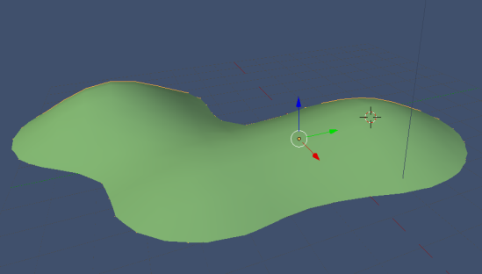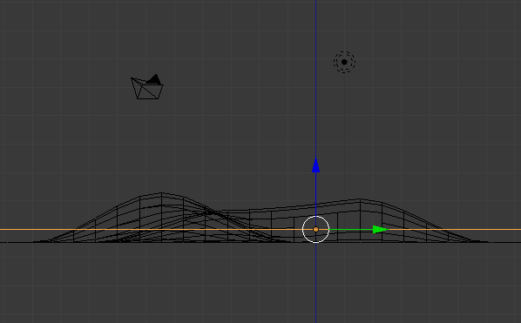 Create any outdoor body of water or a whole planet. For a body of water you can create an island, peninsula, bay, shoreline, or anything else you can imagine, as long as it has both water and land. You can start with your landscape scene. Using a flat grid for water, you can move the parts of land above water or below it using Edit Mode, with *Proportional Editing* to move large area smoothly using one vertex (example above was made by moving only 3 vertices).

* The water is just a **Grid (or sphere if planet) with a blue material**. It is slightly higher than the land grid. Think of the land grid as the ocean floor—but you can make part of the **land Grid (or sphere if planet)** stick out above the water later to make land such as an island.
* Change color of the higher one to blue, lower one to green: Click Material  button (if none in the list, click New), then click the white swatch under diffuse to choose a new color.
* Click Add, Mesh, and choose a Grid (or choose Sphere if you’re making a planet)
* You will have to add two, then one blue for water and one Green or other ground material
* To subdivide a mesh, use Edit Mode, make sure all is selected (orange), Tools tab on left, then **Subdivide** (at least twice, but not many more since the computer can slow down or crash)

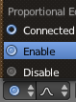

* Now you can use Proportional Editing:
  + At bottom of 3D View, Select vertex section mode:
  + At bottom of 3D View, Click Proportional Editing , Enable:
  + Click to turn off the “Limit selection…” option. Now you can see through the water and pull the land up using the blue arrow:

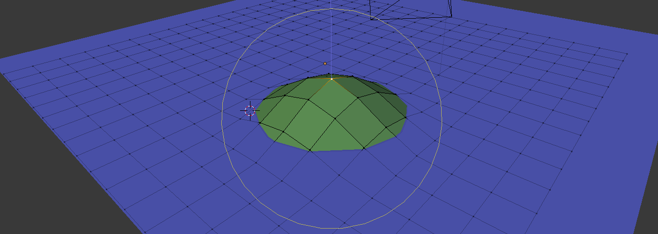

* + **While moving** a vertex you can use the scroll wheel to change the Proportional Size (range of influence) while still holding the button that is moving the vertex.
  + **After** moving it, on the left tool pane you can still change the size of the effect: like any number box in Blender, drag the number left or right to see the result as you change it (or click, type a number, then press enter):



* + After getting the shape of terrain you want, get the smoothing the way you want it:
    - You may want to subdivide again:
      * Modifiers button, Add Modifier, Subdivision Surface

(only if you want to be able to edit the new vertices, hit Apply)

* + - On the left tool pane, hit Smooth to hide the polygons
    - Modifiers button, Add Modifier, Edge Split to keep some edges sharp

See Also:<http://en.wikibooks.org/wiki/Blender_3D:_Noob_to_Pro/Landscape_Modeling_I:_Basic_Terrain>

After you do proportional editing, you can use

Sculpt Mode which has Smooth tool to smooth things out, & has Draw & other tools to further edit the shape freehand.

Using Blender 2.7 for Animation - **Advanced 8.2** - Using Views for Texture Paint **1 of 4**: Splitting Views

(Use a cube if you want to make a terrain, otherwise, save as “3dad6 paint”)

GOAL: Paint multiple textures onto an object such as photographic grass, dirt, and rock.

Splitting Views

Sometimes you will need to change to other views, but you want to keep your other views too. You can do this by splitting on of your views. Each pane that has the view selector is a view. Since the 3D View is biggest, it is easiest to split that:

* *Right-click* the black line that separates the views (cursor must be a double arrow [*circled in red below*], & you must use the black line *below the menu bar* as shown below if there is a one)



* Click “**Split Area**”, then move the cursor where you want to Split the view & click (Escape key would cancel):

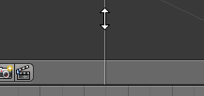

* After you click, the view will be split into two. Now you can change one of the views to a different type of editor by clicking the Editor drop-down box:

`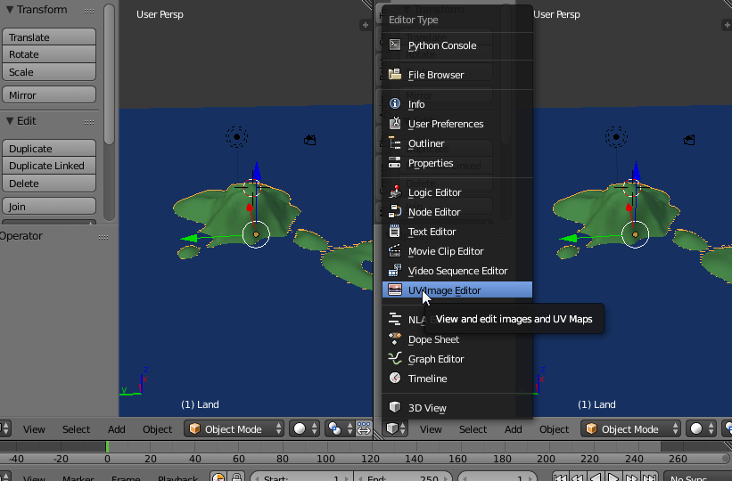

*Now you have both a 3D View and a* ***UV/Image Editor****:*

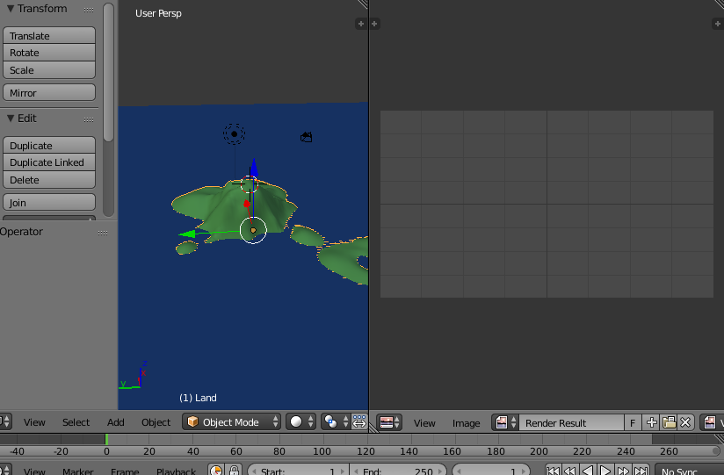

UV/Image Editor lets you see a hardware-accelerated texture,

which is the one used for Texture Paint mode in 3D View

(see next page for how to create the texture needed for this)

* ~~If you want to make a terrain and started with a cube, make the object wide and but short: press ‘s’ once then ‘Shift Z’ once, drag the mouse to make the object very wide (wide enough to provide not only the ground but also a horizon)~~

TIP: *If your camera cannot see the whole scene (things far away) when you hit (Render, Render Image, or 0 on numpad to preview the camera’s view),* select the camera by clicking it in top right tree view, click the camera’s Object Data  button, then change End to about 10000

* *This would be a good time to set the object to Smooth (on left Tool Shelf panel, click Smooth button)*

Using Blender 2.7 for Animation - **Advanced 8.3** - Using Views for Texture Paint **2 of 4**: Unwrapping

The surface of an object is called UV space. A flat texture (XY space) is mapped onto the curved surface (UV space) of an object. Creating the UV Map is called *Unwrapping* since it maps the object to a flat image. Blender’s “*UV Image Editor*” view changes how a flat texture is wrapped around a 3D Object & lets you paint or load a texture.

|  |  |  |
| --- | --- | --- |
| *(This box is only required if you started with a cube)*  Unwrapping the Object  *(If you want the sculpting bonus, follow instructions on last page [under BONUS] before doing these steps)*   * Go to Edit Mode , Edge select mode * Make sure texture shading is turned on (at bottom of 3D View): * **Select enough edges** where if you cut the object on those edges you could make the object as flat as possible without creating noticeable seems. Think of a cardboard box: for example, cut top of and cut side edges too:    + If you did bonus (top of cube is subdivided) avoid the top except for the top edges: do Face select, select the four sides, Edge select, then deselect the bottom 4 edges.  |  |  | | --- | --- | | * At bottom Click Mesh, Edges, Mark Seem… | …now those **edges will be outlined in red dashes** whenever you are in Edit Mode: |  * Make sure you have split the view (see previous page) then change one of the views to a UV Image Editor view: |

* To unwrap all faces, go to Edit Mode, select all: keep pressing ‘a’ until *everything is selected* in orange
* Click “Mesh”, “UV Unwrap…”, “Unwrap”.

|  |  |
| --- | --- |
|  | TIP: You can edit these points in the UV/Image Editor by selecting & pressing ‘g’, ‘r’, or ‘s’ (grab, rotate, or scale). You can also hit ‘a’ to select/deselect all.  IF THEY DISAPPEAR, go to edit mode & select all again. If still missing, unwrap again. |

Now you have to create a new Texture Slot so that painting will work:

* Change the mode to Texture Paint
* In the tool tab on the left, click “Add Paint Slot,” “Diffuse Color,” “OK”
* Change the Image Editor image to see your texture: Click “Render Result” and change it to Material.001 Diffuse Color

Now you can paint onto the object. Before closing, click “Image,” “Save As Image” (after naming, just Image, Save Image)

* Make sure the object doesn’t have a negative scale!
* 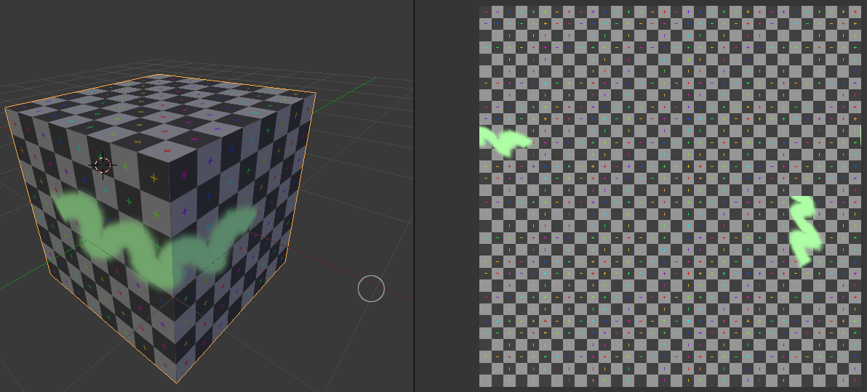In the 3D View, choose “Texture Paint” mode. You may want to change the *Strength* to 1.000 for completely opaque paint especially for the first layer or to paint completely over the UV Test Grid (Press “f” to change size).
* You can choose a color on the left Tool Shelf panel & paint on object with the left mouse button in the 3D View:
* 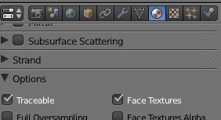Make the far right panel big enough to see the Material  button, click it, Then **turn on “Face Textures”** in Material to make this texture show when rendering…

& to avoid other textures hiding the one you paint, also click on Texture , & *uncheck any textures that affect Color (except Diffuse Color.001)*!

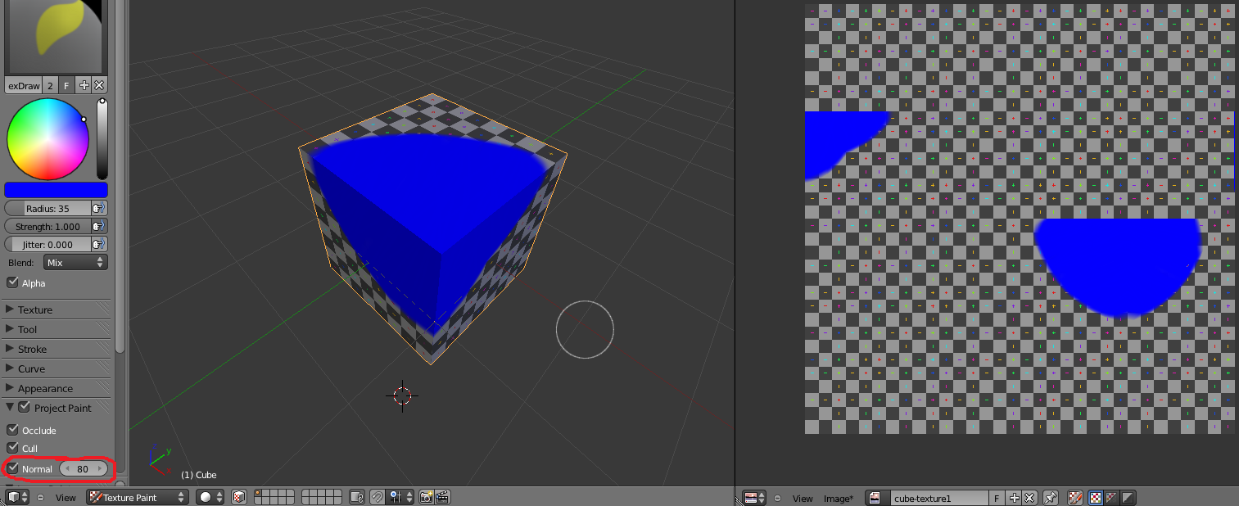Using Blender 2.7 for Animation - **Advanced 8.4** - Using Views for Texture Paint **3 of 4**: Options

*Under “Project Paint” you can uncheck “Normal”**(circled in Red below) to paint more than what’s facing you—(painted blue below). Since “Normal” is the direction part of the object is facing, Texture Paint’s Normal option would limit painting whatever part is angled most toward the camera lens which is curved:*

|  |
| --- |
| TIP: You can click Image, “Save As Image” to*change the texture in other program***.** Image, Replace to *import image* or to*refresh* it (see changes), or Save & restart Blender to just *refresh* (that refreshes all Images not Packed into Blend file).  TIP: There are many brush setting categories (on left Tool Shelf panel as in picture above). At the bottom in “Brush”, “Image Paint Tool” you can choose *Draw, Soften, Smear*, or *Clone* (Ctrl Left Click to set the source for Clone, then left-click to copy that part of the texture to another part of the object) |

Use a TEXTURE as a brush. You can get Creative Commons textures from lovetextures.com

* On the left Tool Shelf, by Texture, click the arrow to show the options under “Texture” in the left pane:

|  |  |
| --- | --- |
| * To create a world texture to use for a tool, click the dark globe under light checker texture tab (see picture) then click New, & in the box before the Plus name it something like “Rock1”, then press Enter     (this is not the usual World button, this is the word textures button under the textures button tab) | * Under “**Image or Movie**” texture:     … click Open, then **choose an Image** (symbol or picture to paint onto the object)—click Open button, then in \\FCAFILES\Resources\Pictures\Maps  Push enter, then on the left by Bookmarks click the plus ‘+’ sign.  Choose the image you want (the Ground folder has ground pictures such as grass and sand). To see a preview of the picture first, click the Thumbnails display mode  button |

* 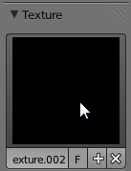On the left tool panel, in Texture Paint Mode, expand the Textures

category on the left then click on the thumbnail to choose a different texture from the list.

IF you can’t paint, maybe you chose a blank texture. Load a texture you can see and try again.

* In the 3D View you can zoom out if you want to paint the texture bigger.
* Under “Curve” there is a curve (on the Tool Shelf). Under the curve the buttons change brush sharpness.
* 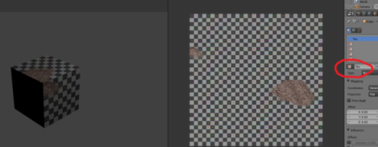Now *set the Texture Paint color to white*(see screenshot at top of page) for the actual color of the texture so it won’t be *tinted*. You can paint that texture right onto the object (notice that in the rendered 3D View it is the same texture as above, but only where it was painted). If you lose the texture or all becomes the brush texture, make you have only **Tex** (circled below) checked in a slot so the Texture Paint image is used:

You must click: Image, Save As Image. From then on you click Image,

Save Image AND File, Save*each time before closing*. If your texture is tinted wrongly, change the color to white on left.

TIP: if you want to paint in the Image Editor, change mode from “View” to “Paint.”

(**Repeat** **“You can use a TEXTURE as a brush” section** to get 2nd texture in another slot, **then again** for a 3rd

—other project requirements are on next page)

Using Blender 2.7 for Animation - **Advanced 8.5** - Using Views for Texture Paint **4 of 4** - Requirements

Texture Painting

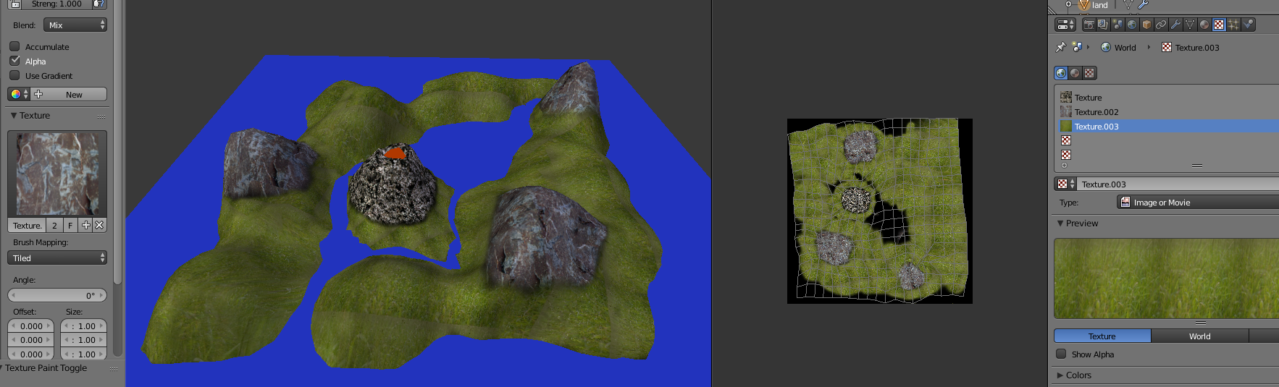

(student work, showing texture added to world textures on far right, texture to save on near right, and texture chosen as brush texture on far left)

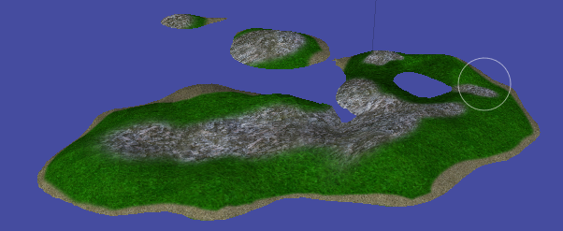

(example)

* Paint at least 3 different textures onto your scene (if you use a cube it must be large and flat like a terrain, and must have at least 3 parts of natural terrain, such as sand+grass+water, rocks+grass+water, snow+ice+rock, or other combination). *TIP: If you want to render but it only renders one of the textures, make sure you select the object button, click the material button, click the texture button, then uncheck every slot that affects color*
* Make sure whole texture is painted, at least the top if a landscape (no transparent areas showing checkerboard)
* Make sure you click *Image, Save Image* each time you are done painting.
* Make sure you Save before you exit.
* 10% of grade is accuracy—whether it looks like you made what you intended.

**BONUS (start with cube then)**: make your terrain bumpy (edit mode, Face select , right-click the top of the object, then on left Tool Shelf panel press Subdivide button about 6 times [a couple more or so can cause crash by exceeding memory if you have 1GB available RAM], then use sculpt mode)

(project is worth double points & grade is based on: creativity, accuracy and whether you met the requirements)